Piazzetta di Resuttano 4, Palermo
info@hryo.eu
+39 91 617 3339
http://www.hryo.org

doga
[Type the company name]
[Pick the date]
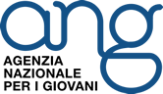
InfoPack
Using Smart(phone)
06th– 12th October 2020, Palermo

INTRODUCTION

Dear partners and participants,
Welcome on board!
This infopack will provide you with all the necessary information about our Youth Exchange “Using Smart(phone)”. Particularly, you will find a description of the hosting organization, project, venue, and other practical aspects. Furthermore, there will be available a short compendium of the activities that we will implement during the YE.

INTRODUCTION TO THE HOST ORGANISATION

The H.R.Y.O. Human Rights Youth Organization is non-profit, non-governmental organisation founded in Palermo in 2009 with the aim to strengthen Human Rights at a local and global level.
Vision:
HRYO believes in a world governed by peace and mutual understanding. We see education as an essential aspect towards creating a reality that promotes and protects human dignity, all aspects of equality and sustainability.
As an organization, we see the importance in supporting local action and developing the potential of a single human being, for small changes lead to big process.
Mission:
Our mission is to facilitate, through various means, the fulfilment of Human Rights and establish an international network of organisations and individuals who are actively contributing to their local context.
We seek to work actively towards a culture of peace, by promoting and taking part in non-violent action towards the liberation from oppression in any form. While taking action we promote, encourage and celebrate the value of diversity of people in society.
Goals:
- To restore Human dignity by using non-formal educational projects that respond to the needs of society and the individual;
- To break down prejudice by connecting different realities and facilitate an intercultural dialogue;
- To raise awareness of oppression and suffering and the issues surrounding them;
- To establish a network that supports local movements in conflict zones;
- To create, facilitate and communicate a pathway towards a culture of peace, respect and sustainability;
- To be of influence in the change of law, rules and policies that protect the Human Rights;
- To establish a local Human Rights Centre that educates about and promotes the integration of Human Rights with daily life;
- To promote culture as a tool in the acceptance and understanding of diversity;
- To create a department specialised in issues that affect the position and role of women in society;
- To use a holistic approach in the achievement of tolerance amongst the new generation;
- To promote peaceful action towards liberation from the influence of mafia and organized crime.

DESCRIPTION OF THE PROJECT

The project Using Smart(phone) addresses a topic which is particularly relevant among young people: the internet use habits and the excessive use of smartphone in their daily life.
The project aims to:
• raise awareness on the addictions connected to the mobile phones and the internet use;
• take full advantages of technological advances without demonizing innovative digital tools;
• create an alternative and healthier way of using digital tools and internet;
• boost a change in youngsters’ attitude, to free their daily life from any conditioning.
• encourage intercultural dialogue and communication on the topic, increase self-empowerment of the young people through the reflection, critical thinking and confrontation on their attitude, know the potential of non-formal education as a method to gain the soft skills recognised by the Youthpass.
The flow of activities will lead the participants towards the analysis of their attitude, through the drafting of a personal report and the achievement of a better consciousness on the addictive approach to the smartphone, through brainstorming, research, interviews, documentaries and other activities.
The path that the exchange will follow intend to trigger a healthier behaviour to face the conditioning that the smartphones can provoke in youngsters' lives. The project wants to give the chance to the participants to analyse the issue by highlighting positive and negative aspects of the advanced technological tools. The development of a healthier approach to the issue will be the basis for the creation of a compelling awareness raising campaign. The participants will produce and distribute stickers and flyers and they will implement a public intervention that will involve the local community.
This awareness raising campaign will drive their engagement on a wider tangible impact: sending a beneficial message that can be spread widely.
Youngsters' perception of the negative effects connected to their internet habits and the smartphone use is a real and pressing issue.
The project wants to break the morbid affection increased by the growing multifunctionality of digital tools and an easier access to the internet during the last decade. At the same time, we don't want to demonize technological advances but creating a positive attitude to the use of internet.
ACTIVITY PROGRAMME
TIME | Day 1 – 6 Oct | Day 2 – 7 Oct | Day 3 – 8 Oct | Day 4 – 9 Oct | Day 5 – 10 Oct | Day 6 – 11 Oct | Day 7 – 12 Oct
9:00/9:30 | BREAKFAST
9:00/11:00 | Presentation of Erasmus + and youth opportunities | Welcome to Using Smart(phone) project | Energizer  Presentation of the interviews  Comparison of the interviews' results | Energizer  Reflecting on the elements of an awareness raising campaign  What is an awareness raising campaign?  Creating an awareness raising campaign - first ideas | Line up – Energizer  What is a “Public intervention?”  Creating the “Public intervention” on the excessive use of the smartphone | Rock, paper, scissors –Energizer  Preparation of the distribution of slogan-stickers | Energizer  Creating videos of the awareness raising campaign I
11:00/11:30 | Icebreaker activities | "Telling our stories" - team building activity
11:30/11: 45 | COFFEE BREAK
11:45/13:30 | Personal Report on the use of smartphone | Brainstorming about use of internet and social media  Research on the use of internet and social media | "Are we addicted to the smartphone? I - brainstorm"  "Are we addicted to the smartphone? II - documentaries" | Awareness raising campaign I - slogans | Creating the “Public intervention” on the excessive use of the smartphone | Distribution of the slogan-stickers | Creating videos of the awareness raising campaign II
13:30/15:00 | LUNCH
15:00/15:15 | Energizer | Human map - Energizer | Quest game: exploring Palermo without the smartphone  Comparing results of the quest game | Stand up if – Energizer  Awareness raising campaign II - stickers | Earthquakel - Energizer | Energizer | Energizer
15:15/16:45 | Getting know each other activities: "Real profile" - "Connect with the Others" | Interviews |  |  | Awareness raising campaign III – flyers | Preparation to the "Public Intervention" | Presentation of the video of the awareness campaign
16:45/17:15 | Preliminary survey |  |  |  |  | “Public Intervention” | Checking the Personal Report on the use of the smartphone
17:15/17:30 | COFFEE BREAK
17:30/18:00 | Evaluation ("pizza's slices"). | Mandala Relaxing Evaluation | Evaluation | Presentation of the slogan-stickers  Evaluation | Evaluation | Evaluation | Checking "Real profile" - "Connect with the Others"
18:00/18:15 | Meeting of youth leaders, facilitators and responsible | Meeting of youth leaders, facilitators and responsible |  |  |  |  | Final evaluation
 | Free time (time for "Connect with the Others")
20:00/21:00 | DINNER
21:00/23:00 |  |  |  | Dinner + Intercultural Night GREECE and ITALY | Dinner + Intercultural Night MALTA and CZECH REPUBLIC |  | Farawell party

INFORMATION ABOUT THE VENUE

PALERMO
Palermo is the cultural, economic and touristic capital of the Sicily Region. It is a city rich in history, culture, art, music and food. Here are some facts about Palermo:
- Located on the island of Sicily, Palermo has a population of around 670,000.
- Spoken languages: Italian and Sicilian.
- Public transport: moving around with public transport is problematic, to say the least. You can only know when you go out, but you’ll never know when you reach your destination. AMAT operates bus and tram services around the city, with one-off tickets priced at €1.40 (valid for 90 minutes after validation). Tickets can be bought at newspaper kiosk, tobacconists or directly on board for a bigger charge (not always available).
- Driving and Parking: crossing the streets is often an adventure. Driving the streets of Palermo can be nerve wrecking for the inexperienced and fainthearted. Expect long queues at traffic lights, drivers sounding horns at each other, and scooters darting all over the place. You often find people ‘working’ in the streets by helping you to find a parking spot. They expect you to pay a small amount of money for their service (0.50ct /1,-)
- Shops and businesses tend to open mid-morning and close for lunch at 1 pm, to then resume operations at 4 pm.
- Dangerous areas: petty crimes, such as purse-snatching, are common (though now on decline). Walking alone at night in the Cassaro district may attract unwanted attention.
- Water: the tap water is potable but the quality is not the best in the historical area of the town.
- On this website: http://palermo.use-it.travel/you can find USE-IT map of Palermo. The content and suggestions in this map are coming from the young locals of Palermo, their recommendations make it possible for you to act like a local too!
- The working venue will be variable according to the activities to be run.

ACCOMMODATION& CATERING
During the mobility the participants will be hosted in a hostel. There will be shared rooms with different options. We encourage all participants to stay with people from different countries in order to have a more intercultural experience! ;)
Each room contains beds, sheets, blankets and towels. Participants are kindly requested to bring necessary products for personal care such as shampoo, shower gel, soap, etc.
There will be served three times per day decent food, which will reflect Sicilian culinary culture, taking into consideration the basic needs of human beings and religious restrictions. (Let us give you a secret: In Italy we eat pasta everyday! So, be prepared to that...) Besides, there will be two coffee breaks during the day. In case that the participants desire to eat something out of the fixed menu, they will need to inform the staff of HRYO in advance and to pay for that course on their own.
There will be free Wi-Fi.

TRAVEL INFORMATION

HOW TO REACH PALERMO CITY CENTRE?
- From the Airport of Palermo you have two options: a) you can take the shuttle bus “Prestìa e Comandé” just outside the airport. There is a bus every half hour. The price is 6.30€ for oneway, 11.00€ for return ticket, b) you can take the train which brings you to the city centre (at Stazione Centrale.) There is a train every half hour and the ticket costs 5.90€. You can book your train from the Trenitalia website.

http://www.prestiaecomande.it/plugins/tratte_1_0/pdf-prestia/5.pdf

- From the Airport of Trapani you can take a bus run by “AutoserviziSalemi”. The price is 11€ for one way. Here you can find the schedule:

http://autoservizisalemi.it/new/orari/ASALEMI_Birgi_Marsala.pdf

- From the Airport of Catania you can take a bus run by “SAIS”. The price is around 15€ for one way. Here you can find the schedule:

http://www.saisautolinee.it/
Attention: The last bus is at 22:00 !

HOW TO REACH OUR OFFICE?
You can find our office at “Stato Brado” on Piazzeta di Resuttano 4. In the Map below you can see the path from the Hostel Mamamia to our Office. It takes 7 minutes by foot:
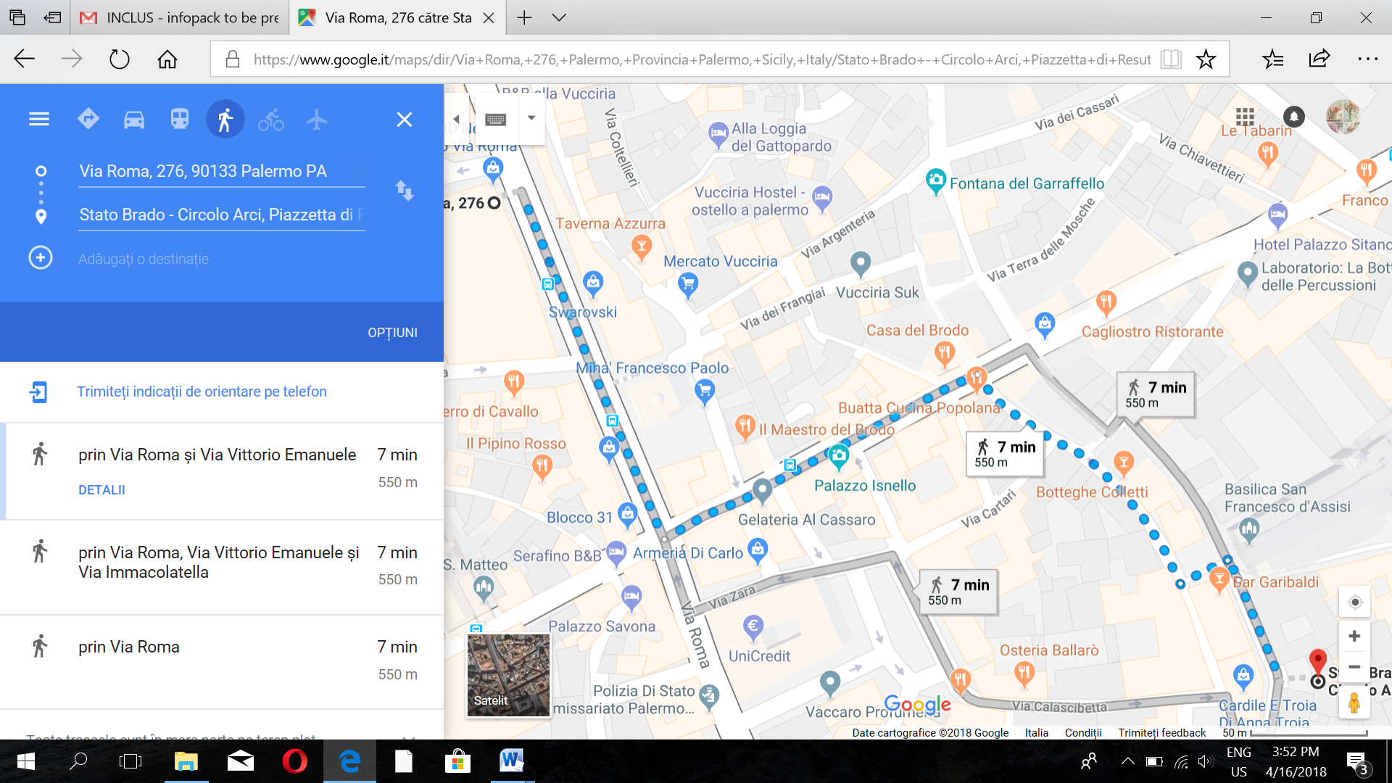

FINANCIAL ASPECT

- Food and accommodation, at basic level under budget conditions, will be covered at 100% for the week of activities.
- Travel expenses will be reimbursed at 100% under the limit provided by the European Commission through distance calculator. In case that the prices are higher than this limit, the participants are expected to pay the rest.
- For Greece: € 275
- For Czech Republic: € 275
- For Malta: € 180
- Important: given the uncertainty of this period, we suggest the participants to buy a travel insurance in the event of a flight cancellation. In case that the prices are higher than the limit provided, the participants are expected to pay the rest.
- Moreover, those who does not have the European Health Insurance Card must pay for their insurance.
- The reimbursements will be done through bank transfer upon the delivery of all travel documents, such as ORIGINAL tickets, invoices, receipts, boarding passes, etc. The coordinator does not take any responsibility in case of the delayed payments sent by the Italian National Agency that may cause any delay in the reimbursement of the travel expenses of the participants.
- Taxi will ONLY be reimbursed in early hours in the morning or late hours in the evening when no public transportation is available. In this case, the participants are requested to provide us with the receipt which is issued to the name of their sending organization specifying the Grant Agreement Number of the project.
- The travel must be realized by the participants on the most possible direct way within maximum 2 days (ONLY 1 day before + 1 day after the activity). In case of longer stays or indirect travelling (holiday travel etc.) there is no chance of reimbursement of travel costs.
IMPORTANT:
- There WILL NOT be reimbursement in case of missing boarding passes.
- There WILL NOT be reimbursement in case of lack of participation in ALL the sessions of the activity programme.

PRACTICAL INFORMATION

WHAT TO BRING?
- Necessary documents such as passports, travel documents, etc.
- Comfortable clothes and shoes
- Personal care products, such as shower gel, shampoo, comb, etc.
- Hair dryer
- AC power (Power adapter)
- Materials for the presentation of your organization (brochures, CD's, etc.)
- Some traditional stuff, food/drink, music, flag of your country for the intercultural evening
- Medicine, if you regularly take any
- Money (better if you exchange already at the departure airport)
- And above all bring joy and lots of positive energy

DICTIONARY

English(Inglese) | Italian (Italiano)
thank you | grazie (GRAT-tzee-yay)
please | per favore (pair fa-VOHR-ray)
yes | si (see)
no | no
Do you speak English? | ParlaInglese? (PAR-la een-GLAY-zay)
I don't understand | Non capisco (non ka-PEESK-koh)
I'm sorry | Midispiace (meedees-pee-YAT-chay)
I like | Mipiace (meepee-YAT-chay)
How much is it? | Quanto costa? (KWAN-toh COST-ah)
That's too much | É troppo (ay TROH-po)
Good day | Buongiorno (bwohn JOUR-noh)
Good evening | Buona sera (bwohn-ah se-rah)
Excuse me (to get attention) | Scusi (SKOO-zee)
Excuse me (to get past someone) | Permesso (pair-MEH-so)
Where is? | Dov'é (doh-VAY)
...the bathroom | ilbagno (eel BHAN-yoh)
...train station | la ferroviaria (lah fair-o-vee-YAR-ree-yah)
Goodbye | Arrivederci (ah-ree-vah-DAIR-chee)

Please do not hesitate to contact us for any questions you may have!

LOOKING FORWARD TO SEEING YOU IN SICILY!

ANNEX: The consent of the participant

I, undersigned, have read and understood the InfoPack and I agree on all the details.

Date-Venue:
Name:
Signature:

